Edith Nourse Rogers STEM Scholarship Application  
(VA Form 22-10203)

Table of Contents

Rogers STEM Scholarship Overview 2

User Access 2

Navigation 2

Direct URL 2

VA.gov Homepage 2

VA.gov Main Menu Dropdown 3

Education Hub Page 4

How to Apply 5

Functionality 6

22-10203 Introduction 6

Chapter 1 – Applicant Information 7

Chapter 3 – Program Details 8

Chapter 3 – Program details – STEM degree and school details 10

Submission & Submission Confirmation 11

Major Issues and Error Messages 12

# Rogers STEM Scholarship Overview

The Rogers STEM Scholarship will provide up to nine months of additional Post-9/11 GI Bill benefits (to a maximum of $30,000) to qualifying Veterans and Fry Scholars seeking an undergraduate STEM degree or who have earned a STEM degree and are seeking a teaching certification.

## User Access

Users do not need to be signed in to apply for this scholarship. The application can be submitted for processing whether or not they have a VA.gov account.

## Navigation

Direct URL  
<https://va.gov/education/other-va-education-benefits/stem-scholarship/apply-for-scholarship-form-22-10203/introduction>

VA.gov Homepage  
The Rogers STEM Scholarship application can be accessed by selecting “Apply for education benefits” under Education on the VA.gov homepage:

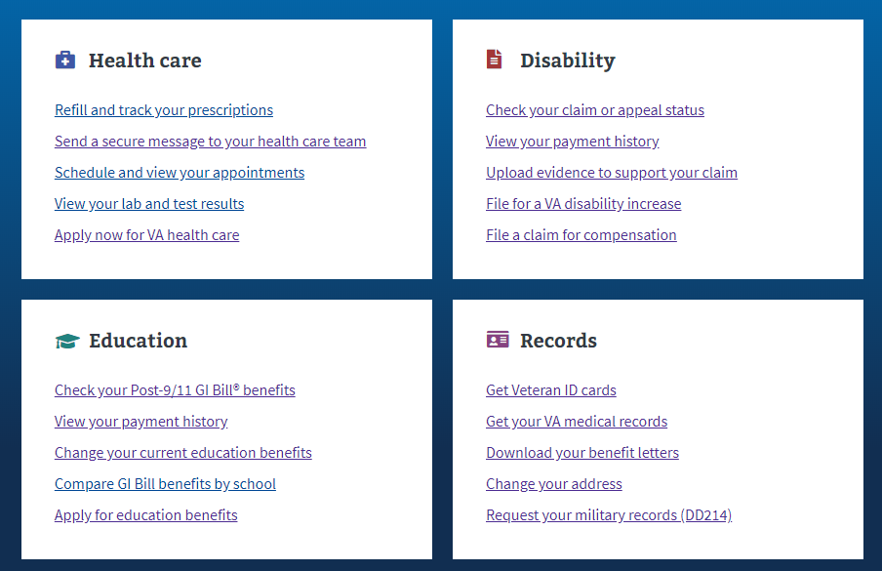

VA.gov Main Menu DropdownThe “How to apply” link can be accessed by under “Get education benefits” by selecting “Education and training” from the “VA Benefits and Health Care” main menu dropdown:

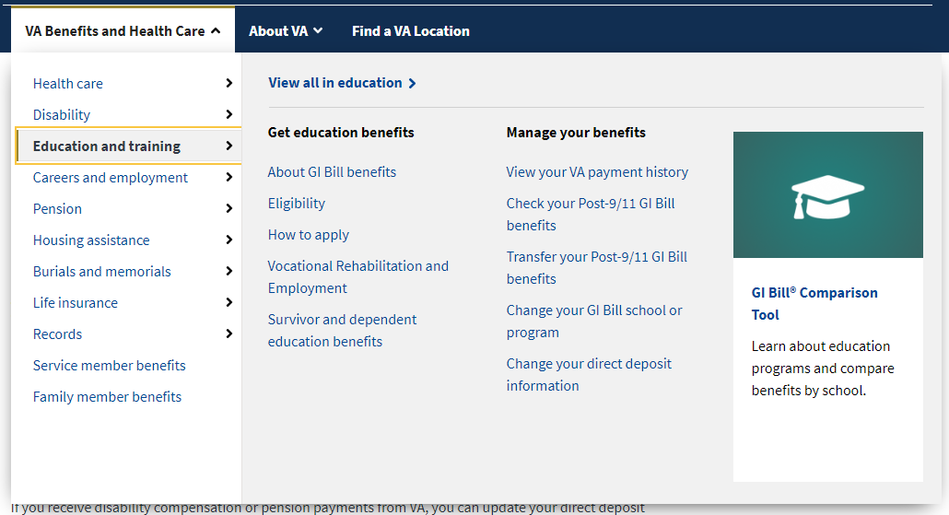

Education Hub Page  
The “How to apply” link can also be found at <https://www.va.gov/education/> under the “Get GI Bill and other education benefits” section.

### How to Apply

Once the applicant is on the “How to apply” page (<https://www.va.gov/education/how-to-apply/>), they can complete the application wizard to be redirected to the Rogers STEM Scholarship application.

## Functionality

The Rogers STEM Scholarship will provide up to nine months of additional Post-9/11 GI Bill benefits (to a maximum of $30,000) to qualifying Veterans and Fry Scholars seeking an undergraduate STEM degree or who have earned a STEM degree and are seeking a teaching certification.

### 22-10203 Introduction

On the introduction page, the applicant is presented with a subway map of the life-cycle of the application and can proceed to applying by signing into VA.gov, which will pre-populate portions of the application with available data, or they can continue unauthenticated.

### Chapter 1 – Applicant Information

Completing the application follows the same workflow and pattern of other forms on VA.gov, asking for relevant information used in the processing of the form. If the applicant has logged in, this page will be prepopulated with available information.

### Chapter 3 – Program Details

The scholarship has 3 eligibility criteria that must be met in order to be approved:

1. Are using or recently used Post-9/11 GI Bill or Fry Scholarship benefits
2. Have used all your education benefits or are within 6 months of doing so.
3. Are enrolled in an undergraduate degree program for science, technology, engineering or math (STEM), **or** have already earned a STEM degree and are pursuing a teaching certification.

The first criterion is covered in Chapter 2 of the form, which is a frequently asked question. The second and third criterion are asked in Chapter 3 where the new form behavior can be found.

If any of the 3 eligibility criteria questions are answered in a way that indicates that the applicant may not be eligible for the scholarship, they are redirected to a summary screen that outlines where they may be ineligible for the application.

In the screenshot above, it indicates that the applicant met the first two eligibility criteria but failed to meet the third criteria. As a result, they are encouraged to exit the application. However, they can continue through to the end as the application is not intended to provide a final judgement on their eligibility.

### Chapter 3 – Program details – STEM degree and school details

On the final page of Chapter 3, the applicant is asked to provide information regarding the school and program where they plan to use the scholarship benefits. The final section of this page also asks for school contact details; the student ID and the student email address. This information is used to validate the student’s information as part of the application approval process.

### Submission & Submission Confirmation

After completing the STEM specific questions, the applicant is taken through 2 additional chapters of questions before they are able to complete and submit the form. These 2 remaining chapters are similar to other form behavior. Upon submission, the applicant will receive a confirmation screen that they can print for their records.

## Major Issues and Error Messages

There are no major issues or error messages that are unique to this form.